

**Department of Computer Science & Engineering**

**Project Report**

**Project Title: Gesture Controlled Wheelchair**

|  |
| --- |
|  |

|  |  |
| --- | --- |
| **NAME :** | **Sadia Alam**  **(C173213)** |
| **Submitted to :** | **Mr. Touhidul Alam, Ph.D** |
| **Project Member** | **C173213, C173234, C173218, C173240,C173207** |

1. **Executive Summary of the project**

To assist the paraplegic patients, a gesture-controlled semi-autonomous wheelchair is proposed in this paper. Here an android application uses the accelerometer sensor which in turn detects the hand movement, and based on the movement; two DC motors are controlled to navigate the wheelchair. This is achieved by the Bluetooth module HC-06 which receives the transmitted data from the mobile phone, forwards it to the microcontroller Arduino UNO, which further conveys the data to the motor driver, via some designated pins. Eventually the motor driver runs the dc motor, with the help of a 12V lipo battery. The enable pins of the motor driver with the PWM pins of the arduino UNO are being used to control the speed of the dc motor. The android application serves as a master and the robot as a slave.

1. **Existing works**

ANDROID BASED APPLICATION FOR WIRELESS CONTROL OF WHEELCHAIR by Archana Hule, Rekha Bandage, Pratik Shah, Rashmi Mahajan

1. **Problem Statement**

Obstacles aren’t detected in those works, which might result into accidents, if the Bluetooth fails to pair with the device. Moreover if the person gets lost accidentally, they wouldn’t be traced easily. Hence our future work would be using ultrasonic sensor and two sonar sensors to detect the obstacle in the front or back direction of the wheelchair to avoid clash or accident. In case of an accident, it has the ability to detect the collision and to inform the family member by sending an SMS through GSM modem with location information.

1. **Motivation**

The wide spread prevailing loss of limbs is day-to-day scenario due to wars, accidents, age and health problems. Moreover, Quadriplegic patients are affected by paralysis of all four limbs, and therefore they cannot move without the assistance of other people. Therefore a wheelchair monitored with the Android mobile application is developed to help the disabled patients by using application to control the movement of wheelchair in different directions. The main advantage is to design a wheelchair that will be controlled wirelessly and will be very easy to operate it with no physical efforts. This application will be a boon for many patients who are dependent on wheelchair for their mobility. This project will help the disabled to operate the wheelchair on their own.

1. **Objectives**

* Designing a Bluetooth controlled Wheelchair (Robot) which has following features-

1. Gesture Controlled
2. Can move at any direction with regulated speed

* To analyze the performance of the developed gesture controlled wheelchair.
* To familiarize with I/O pins of microcontroller.

1. **Methodology**

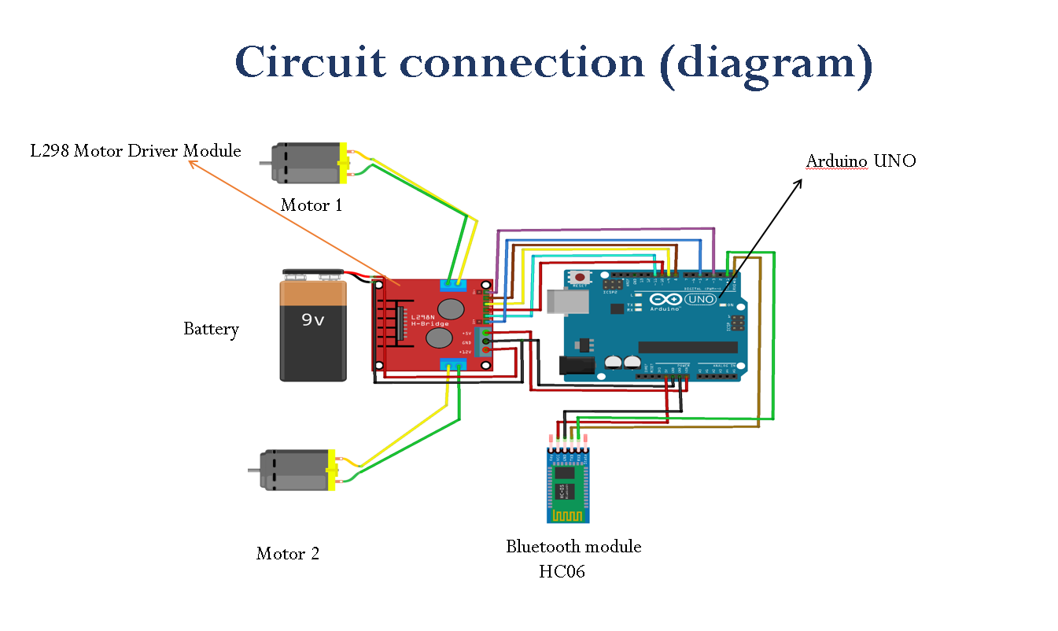

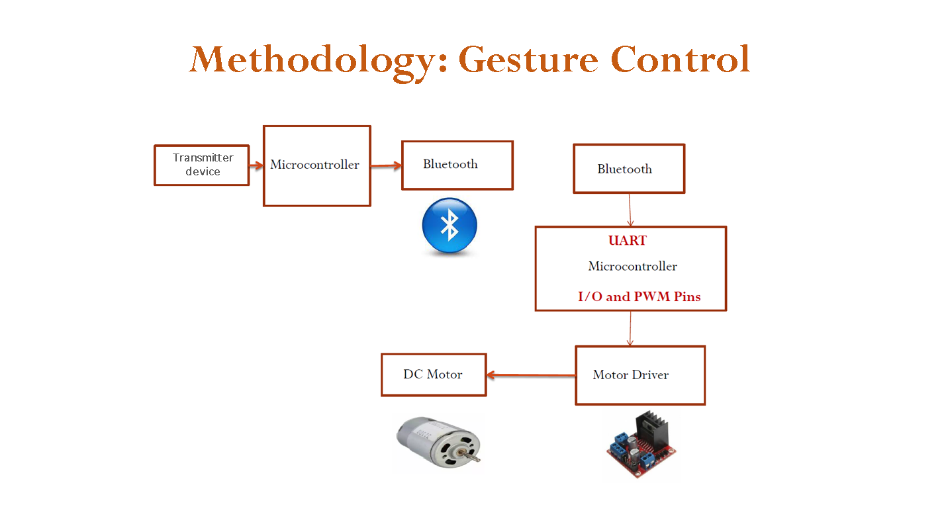

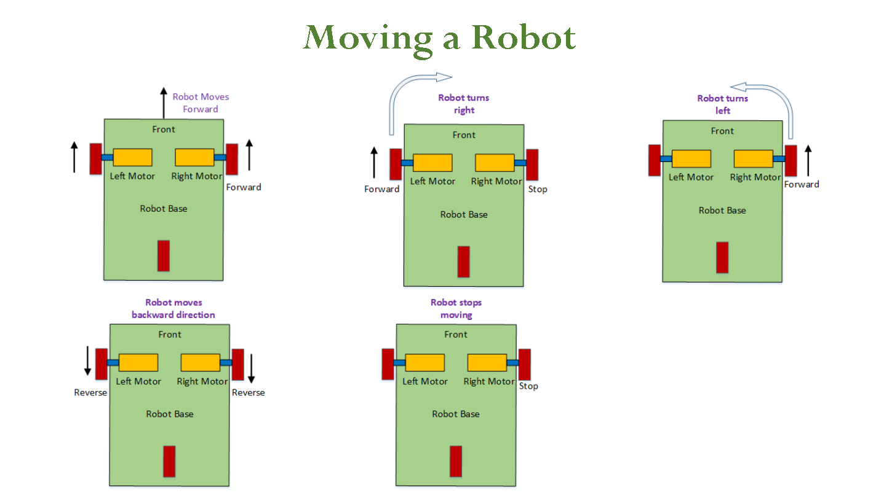

**Working principle :**



PAIR UP

**Receiving Unit**



**Transmitting Unit**



1. **Flow of Activities for the project**

**No**

Simulate to check speed control

Speed control analysis

**Yes**

Change the code

**No**

Examine navigation control

Working in the correct direction?

?

Results?

Simulate in a chasis

Specify proposed sensors and parameters for design

Literature Review

Analyse Existing gestured controlled robot

ann

Lower the value for pwm pins

**Yes**

Satisfactory?

Results?

Mount it on a wheelchair

1. **Result and discussion:**

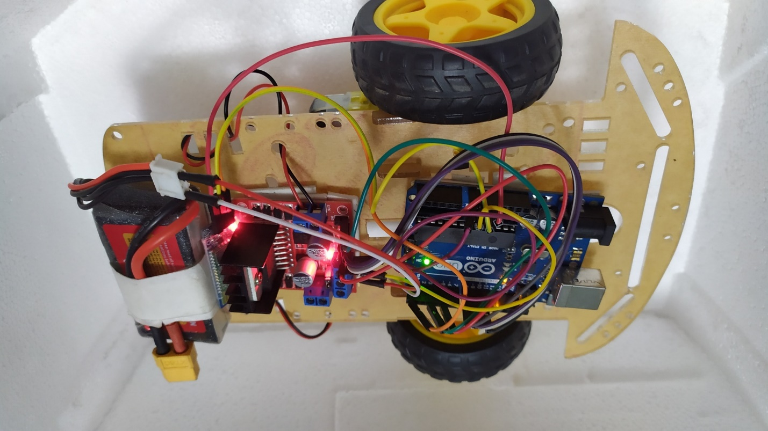

Because of having trouble with HC-05 bluetooth, transmitter couldn’t be built as it wasn’t pairing up. The ball caster on the front, disturbed the motion of the forward and backward motion, which can eliminated if more two wheels could be used on the front row. Placing the Bluetooth module near the heat sink should be avoided as it gets short-circuited and will get disconnected frequently. To sum up, the prototype worked according to expectation.

1. **Expected Outcomes from the Proposed Research**:

Our goal of this research is to provide assistance for the disabled persons, with the help of this gestured controlled robot. Because of being less complex and cheap it can be easily mounted on a wheelchair. In addition, android application can scan the valid input at a faster rate and hence control the movement of wheelchair.

1. **Gantt Chart of Research Activities**

|  |  |  |  |  |  |  |
| --- | --- | --- | --- | --- | --- | --- |
|  | Year | **2019** | | **2020** | | |
|  | Project Activities | **N** | **D** | **J** | **F** | **M** |
| **1** | Literature review |  |  |  |  |  |
| **2** | Project development |  |  |  |  |  |
| **3** | Writing up report |  |  |  |  |  |

1. **The Importance and Benefits of the Research to the Industry or Society:**

The project implementation will help all the people who are dependent on wheelchair for their mobility. Disabled people can control their own movements or any other people can control their movement as well. It can be installed for hospitals, airports,etc. Moreover using mobile phone as a transmitter makes it user-friendly.

1. **References**:

* [**https://www.ijrte.org/wp-content/uploads/papers/v8i1s4/A10140681S419.pdf**](https://www.ijrte.org/wp-content/uploads/papers/v8i1s4/A10140681S419.pdf)
* [**https://www.researchgate.net/publication/277907692_ANDROID_BASED_APPLICATION_FOR_WIRELESS_CONTROL_OF_WHEELCHAIR**](https://www.researchgate.net/publication/277907692_ANDROID_BASED_APPLICATION_FOR_WIRELESS_CONTROL_OF_WHEELCHAIR)